Simultaneity in Heterogeneous Covid-19 Epidemics with

CovidSIMVL Agent Based Simulation

Ernie Chang, MD PhD

Ken Moselle, PhD

**Introduction**

CovidSIMVL is an agent-based simulation system that permits the deep exploration of scenarios for SARS-2-COV epidemics, and some of its capabilities, metrics and applications have been previously reported [xx,xx].

While the classic modeling approach to Covid-19 epidemics use an equation-based data fitting approach with four compartments (SEIR), and more detailed models adopt a “patch” extension for heterogeneous environments, CovidSIMVL uses an agent-based physical contact and stochastic approach to simulate the movements of agents between heterogeneous environments according to roles and schedules for each agent.

CovidSIMVL uses the viral temporal dynamics model described by Xi, He {*Nature Medicine Aug 2020*}, and has the ability to set parameters in two classes – the first are population and case definition files that set the characteristics and movements of individuals and their representative cohorts; the second are parameters governing mobility and infectivity, which we term “mingle Factor” and “Hazard Radius”, and “Red Days”, the number of days that active cases remain in circulation before isolation or hospitalization.

The richness of this sandbox tool leads to challenges in understanding the many interactions that go on in the repeated execution of the schedules of the population cohorts as they move in and out of the designated spaces. It is not what spaces, and when, that each person move to and from, but also the relative infective states of the other agents in those spaces, that determine the end result of infections within a space, and overall for the total population.

**METHODOLOGY**

In this paper, we consider a heterogeneous population of typical family structures, in a Multiverse of nine Universes, that include school areas, a Long Term Care Facility, and a Bar/Reception area. The population and space structure has been defined in a previous report “The Anatomy of …” and we summarize it briefly.

The 100 agents are divided in 18 families, with representative social structures like married couple with and without children, multigenerational families, single parent families, grandparent – children families, etc. The school has Classroom1 and Classroom2 as well as a Project/Lab/Games room, a Playground, and a Teacher’s Lounge. The social roles are: children, teachers, spouses, grandparents, Long Term Care (LTC) residents with and without outside family membership, LTC staff, Bar/Reception staff.

There is a daily schedule that govern the movements of each of the 100 persons by hour of day, so that students in 3 groups of 10 attend class, projects, lunch and playground, while 6 teachers supervise or work in the teacher’s lounge. Each of these spaces are Universes, with their own inherent mingleFactor “mF”, while students and teachers have individual mFs as base values, which can change according to their roles in different spaces.

The role of spouses and grandparents are to visit LTC (Universe 6), and to be clients in the Bar/Reception (U7). There are 28 LTC residents, 10 of whom have external families. Visitors are not matched to LTC residents, just to the Universe. LTC staff are divided unequally by work shifts, and go home or to the Bar after work. LTC residents remain in LTC. The HOME Universe (U8) is where all persons go who are not working or at school or visiting LTC or the Bar, and is different from the others in that only members of the SAME FAMILY can transmit to one another.

The actual composition and movement schedules takes more than 4,000 lines of text, and is available in the repository <http://github.com/ecsendmail/MultiverseContagion>.

This complex structure is compliant with other model approaches to heterogeneity, such as age-group social mixing, family structures, different durations of exposures, community and workplaces.

Using standard settings of HzR=5 and mF=1, with RedDays set to the unmitigated 8 days, the CovidSIMVL with run with the population definition and scheduling file of 100 persons, and an initial case file of 5 students, until it terminated with no further potential infections. This means that across the entire population, there were no yellows (incubating), blues (pre-symptomatic), reds (symptomatic and infectious).

The CovidSIMVL is implemented in Javascript and HTML, and runs in modern web browsers. This trial was executed in Microsoft Edge, on an Intel-based tower PC with an i5-3570 processor and 32GB of RAM, running 64-bit Windows 10.

The console.log, a part of the Edge devtools, reported on every infection, and any changes in the state structure (number of green-yellow-blue-red-orange counts) within each Universe and the Multiverse, was used to analyse the results of the trial, as reported below.

To address an important point: this is not a predictive trial, but a methodology exploration, and therefore we take this single trial to be representative of the envelope of results that repeated runs with the same parameters would produce. Repeated trials would therefore be expected to follow the analytical metrics presented below.

**RESULTS**

The trial terminated at generation 1406 (each one representing an hour in the schedules), with 21 survivors, and 79 orange (inert post-symptomatic) agents. The calculated R0 for the entire population was 1.71. This was done by identifying all orange agents (past their infective days) that had successful infections of susceptibles, adding these up and averaging them.

The SEIR graph for the entire population , and the associated composition chart by generation (time), is shown here.

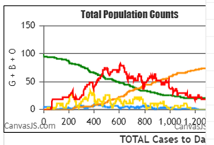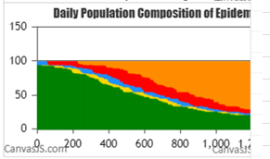

There are nine separate universes, and their final states look like this:

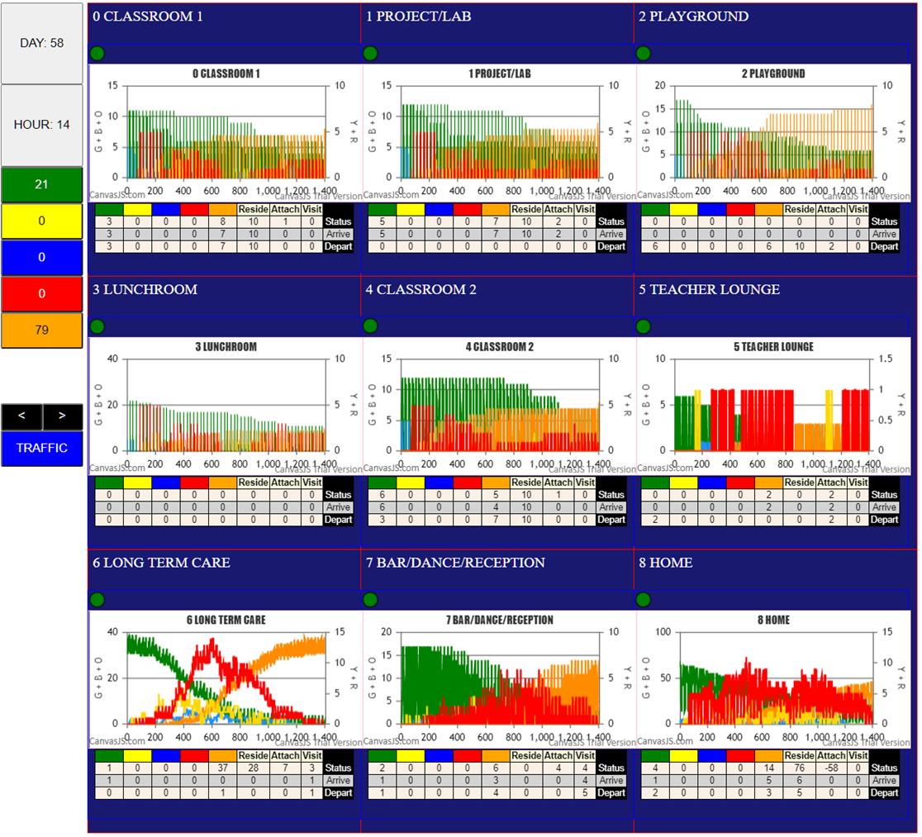

Each of the panels is its own Universe, and the chart shows the history of the counts of the different agents in their viral states (G-Y-B-R-O) as time (generations) progress from left to right. Note in U6 LTC that the green lines start with a low of 28 (near midpoint between 20 and 40) and a high of 40. This is due to the 28 permanent residents, and the visitors daily, which each of whom actually come and go at their own times.

Over time, an infected agent comes into LTC, and eventually, not necessarily the first visit, infects some other agent (which may or may not be a LTC resident, since there are staff and other visitors present), but this infection may stay if a LTC resident, or be carried out with the non-resident, to potentially infect others in other Universes. This is the challenge – understanding and representing the dynamics of these events in a holistic way.

A chart like U7 have greens which fall to baseline (zero) daily, because the Bar shuts down at midnight, and opens again at 10am. This chart is too coarse to represent such details. Furthermore, these charts show the composition of the cohorts on a daily basis for different states, but not whether an infection occurred there.

They do not show the infection and survival rate among the cohorts (children, LTC staff, bar staff), nor of the Universes (is Playground more infective-risk than Classroom1), nor of other cohorts like age-groups. For this, we have to use the console.log, which reports each infection, who was infected by what transmitter in what Universe at what generation and the family members of each and their states.

From this, using Excel and the sort and count functions, we are able to obtain the rates for each grouping, as shown below, with their theta values. To explain, if 10 infections took place withiin a specific Universe over the entire period, the first at T.first, the last at T.last, then the delta is

T.delta = T.last-T.first and theta for the Universe is T.delta/#infections = T.delta/10

Theta is the time interval between infections. A longer theta is obviously a slower epidemic, and more important, may imply lower risk for the context under consideration.

***Calculation of Thetas***

Here is a section of the data derived from the console.log for infections.



By sorting by various columns, it is possible to find the associated generation T.first and T.last for the context in mind.

Thus, sorting by “infected”, allows the separation of cohorts by Students (0-29), Teachers, and so on. Sorting by Universe will enable us to calculate the thetas for different Universes (through the count of total infections that took place in each Universe). Similarly, sorting by AgeGp of the infected will create the theta values for each age group.

Here, to start, are the values for the whole Multiverse, the Students, and Teachers.



For the Multiverse, the initial population was 100 but 5 students were initial cases (pID 10 – 14), so the susceptibles were 95 in number. Of these, we counted 73, so there were 21 survivors. Therefore the survival rate overall was 21/95 = 27% and the infective rate was 78%.

The first infection was at generation 29, and the last as generation 1115, for a T.delta of 1086.

This, divided by the number of persons infected (73) gives us a theta.all of 15.

This value means that over all the Universes, there was a new infection on average every 15 generations. However, we do not know in what Universe, or what cohort, these infections were, nor the dynamics (changes in infections at different times during the epidemic).

Nevertheless, for the Students overall, there were 25 susceptibles (since 5 of them were initial cases), and therefore, with a T.delta for them of 1009, the theta for students overall was 78.

The corresponding calculations for Students.GpA, Students.GpB, and Students.GpC gave theta values of

140, 61 and 220. Group B only had 5 students as susceptibles (pID 10-14 were initial cases), of which two were infected, so with a T.delta of 122, the theta.GpB was 61. The schedule for the three groups was designed as follows, with A, B and C representing student groups, and the third row being the mingleFactor intrinsic to the Universes. Thus, Playground (U2) has a higher mF than the Classrooms.



Gp A has 2-U0, 2-U4, 1-U1, 1-U2 and 1-U3 hours

Gp B has 2-U0, 1-U4, 2-U1, 1-U2 and 1-U3 hours

Gp C has 1-U0, 3-U4, 1-U1, 1-U2 and 1-U3 hours

Gp A and Gp C have 4 hours of mF 0.5 Universes, and 1-U1 hour at mF of 1.5

GpB has 3 hrs of mF 0.5, and 2 hours of mF 1.5 (U4)

So Gp B has slightly more risk at a total of 3x0.5 +2x1.5 = 4.5 mF-hours of class and project time

Gp A and Gp C have 4x0.5 + 1x1.5 = 3.5 mF-hours

Thus, it may not just be a stochastic outcome that Gp B has a theta of 60, compared to much higher thetas for GpA and GpC. At the least, these differences are consistent with the exposures.

*Theta for LTC residents*



As expected the LTC residents have the lowest theta of all the cohorts, and there is no difference between LTC with and without family, as visitors are not specific, and HOME is U8, so the infections among family members alone only happens in U8. Note that this does not preclude them infecting one another as individuals if they happen to be in another Universe together.

The theta for LTC residents as a whole is 31, which attests to the simultaneity of the infections happening in the 2 groups. We will come to terms with this below.

*Theta for Staff (LTC and Bar)*



For LTC staff as a whole, theta is 63, while for Bar Staff, it is 82. This again is consistent with the observation that more infections happen in U6 than elsewhere (which we will come to in the section on Simultaneity). Note that all LTC staff have become infected, which is not true of Bar staff, in both shifts.

Within LTC staff, the day and evening shifts have higher thetas than the night shift. This may be due to the following dynamics. During the day and evening, there are many visitors in addition to residents and staff. At night, even though the residents are given a low mF during sleep, the staff have a mF of 6. So even if the residents are not moving, the staff are, and if they come across an infective resident, they will become infected. This suggests that mitigation is improved in a crowd, which might be counter-intuitive, but makes sense in the overall picture. We will discuss this below.

The Bar staff as a whiole has a theta of 70, with T.delta of 563, but interestingly, the day shift and evening shifts have T.deltas of 233, and 331, which upon further examination, shows that the day shift infections took place in the first time segment T.475 to T.708, while the evening shift infections were in the subsequent time segment T.707 – T.1038, so that the thetas for the shifts are the same, approximately, as for the whole group. Each day and evening shift happens every 24 generations, and there is no particular reason why the evening shift should consistently not have been infected in the first part of the entire time period. To know whether this is a stochastic outcome, or whether there is some structural basis, we will need to repeat this trial a number of times.

*Theta for Spouses and Grandparents*



Spouses and grandparents go to LTC as visitors (an hour a day for some of them) and to the Bar/Reception. In this trial 2/5 spouses became infected, and 4 of 7 grandparents, so their thetas are 45 and 83 generations between infections respectively. These appear to be on par with persons involved in U6 LTC.

*Theta for the Universes*



We can tell at a glance that U6 LTC has a theta of 20, while the playground U2 has a theta of 54, approximating U7 which is Bar/reception. Classroom1 had no infections, nor did the Project U1, while Classroom2 U4 has a theta of 247. It is interesting that the Lunchroom has a theta of 108, double that of the Playground.

The major difference between them is that Playground has an intrinsic mF of 5, while Lunchroom was assigned 3. This means that Playground tends to have more activity, a higher probability of contact, and therefore a lower theta than Lunchroom. This indeed is what the trial shows.

The different Universes not only have different thetas, but they have very different populations of infected, and very different rates. Thus, the high infection rate is U6 LTC with 55%, while Lunchroom U3 has 6% and U7 Bar has 7%. We introduce the first SIMULTENEITY chart, which simply displays Universes across time, with infection events highlighted as red circles.

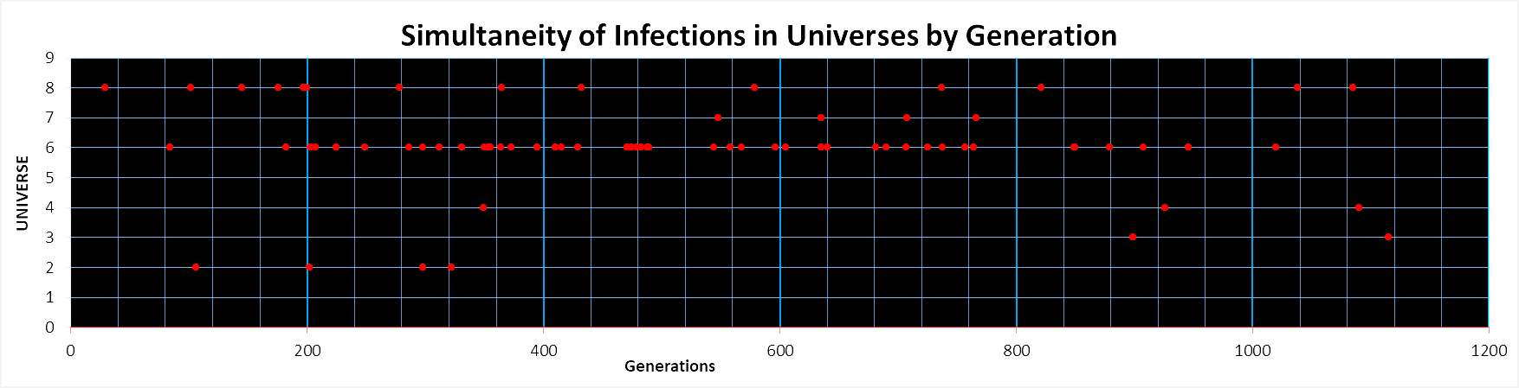

Now we can see that the four U2 Playground infections occur near the beginning of the trial, whereas the two U3 Lunchroom infections occurred late in the trial. The Classroom2 U4 infections were spaced between the first, approximately gen 350, and much later, at approximately gen 920 on. The four U7 Bar infections happened in a loose cluster between 550 and 760.

Universe 8 HOME infections has spacings which gradually increased with time, while U6 shows many infections from 200 to 1000, in assorted temporal clusters. One can clearly with this visualization see what theta means – the average spacing between infections, and also how thetas can be taken with various time frames, eg from 0 to 200, from 200 to 400, or the first half of the trial vs the second half.

From this chart, we can also look at simultaneous events by generation, and observe that in this trial, there are relatively few events occurring at the same generation, perhaps only at gen200, and perhaps two at gen 710 and again at 770.

This chart does not tell us which agent is infecting, or being infected, in these events, nor the movement of agents with different viral states between the Universes, and how this influences infections in a Universe.

*Thetas for AgeGroups*

The age groups were not chosen from a demography of Canada, or BC, or any other place. Rather, they grew organically from family groupings and the rather specialized notion that the school is a lower Grade school, and that there is a relatively large population of LTC and grandparent seniors. Nevertheless, we can sort by AgeGroup, and arrive at the following table.

Some observations we make are; first, that the attack rates are not the same as the age group percentages of the entire population. For example, AgeGp 9 has a 92% rate of infection, and is clearly not 92% of the whole. The lowest are 0% for AgeGps 5 and 6, which only had 2 agents, each, while AgeGp 7 with 6 had all of them infected.

The table shows that there are 2 Grandparents in the Age60 group, two in the Age70 group, two in Age80 group, and one is Age90+. GP2 and GP3 in the Age70 group both became infected, early in the trial, between gen 102 and 471.

At this point we cannot tell except from the Excel tables just where the AgeGp7 persons got infected. We will be able to from a later SIMULTANEITY table.

***Summary To this Point***

So far, we have the overall duration and survival for the multiverse trial, and an analysis of thetas for the different cohorts and universes point to U6 as the place where most infections took place, and the schools being relatively slow in infections, with highest theta values. The first SIMULTAEITY chart shows that parallel activity in the Universes are rarely synchronous, and quite fragmented in terms of activity levels, and heterogeneous in the distribution of infections across time.

**TRANSMISSION TREE**

Previous work have indicated that the epidemics with survivors and slower rates have more heterogeneity, which can be expressed by the balance of, and between, transmission trees. Furthermore, the general acuity of an epidemic is also reflected by the degree of parallelism (simultaneous active infectors) and the depth of the transmission trues, through a synthetic metric we called the Q-value.

The five initial infectives (10-14) only resulted in 4 trees. They are (with apologies to page limitations) :

 rooted at 11

 rooted at 12



rooted at 13

 rooted at 14

Q = ((Leafs/AvD)/Gen) * New Infections * 100

Calculations are done offprint, and the results for Q for the five sub-trees from the initial cases are:



First, the Q-values show that the tree rooted at node 13 has a Q-value of 34.84, which is a reflection both of the population size that the tree encompasses as well as a measure of its structural configuration and its execution over time. The larger this number, the more it dominated the progress of the epidemic.

The other values of Q are less than 1, and insignificant in terms of the overall activity of the epidemic described by this trial.

The “Average” is the average pf the number of nodes in the five subtrees if the entire set of trees were totally balanced. The balanced tree structure would have the maximal parallelism and the shallowest depth (if the balance is maintained in each subtree of all the subtrees)….but we just consider the top level balance for now.

Then Delta is the absolute difference between the actual nodes of the tree and the ideal balanced tree, and their sum is our measure of the degree to which the trees fall short of being totally balanced.

The observation has been made in an earlier paper on Wave versus Particle Dynamics of an epidemic that Particle dynamics are at the extreme similar to rapid exponential growth, and lead to balanced shallow but broad trees. The Q values and the sum of the divergences from balance are ways to estimate the intensity of epidemics in the range from very slow to very rapid.

***CAVEAT:*** Here we have collected the trees for the entire Multiverse over the duration of the trial. This has given us transmission chains that span the Universes, as one infection leading to another may or may not be within the same Universe, and the time stamp of an infection does not map to its level in the tree.

At present, the presentation of transmission trees that allow us to visualize both their Universe of action and their time of infection remains a challenge for representation. We are confident that a single chain of transmission is incremental in time stamps. The next SIMULTANEITY charts are a step toward this, but not yet a complete solution.

***Changes in Viral States of Cohorts in Universes***

The definition of cohorts arriving at, and departing the Universes over fixed schedules means that we have a fixed population daily (even though CovidSIMVL’s schedule can sustain deviations from the regular routine – we have not used this as yet). This population’s viral state will change if one or more are infected, either at this Universe in a previous interval, or in some other Universe.

The change in viral state is expressed by counting the numbers of Green-Yellow-Blue-Red-Orange agents in the Universe at every generation, and these values are output to console.log if there is a change in these counts from the previous generation. The console.log for these state compositions look like this.



We have sorted the raw console.log and this is the juncture between the recording of S0, which is the Multiverse (keeping track of the entire population of 100), and the universe U0. The syntax is:

Generation G:Y:B:R:O counts

From this we can visualize the entirety of the changes in viral structure of the population in the Universe and the Multiverse with time (generations) as the common parameter. This is the capture of the data that goes into the SEIR graph for the Multiverse, which appears in the screen capture of the Multiverse as shown below.

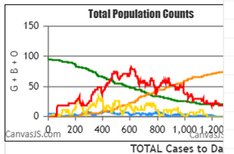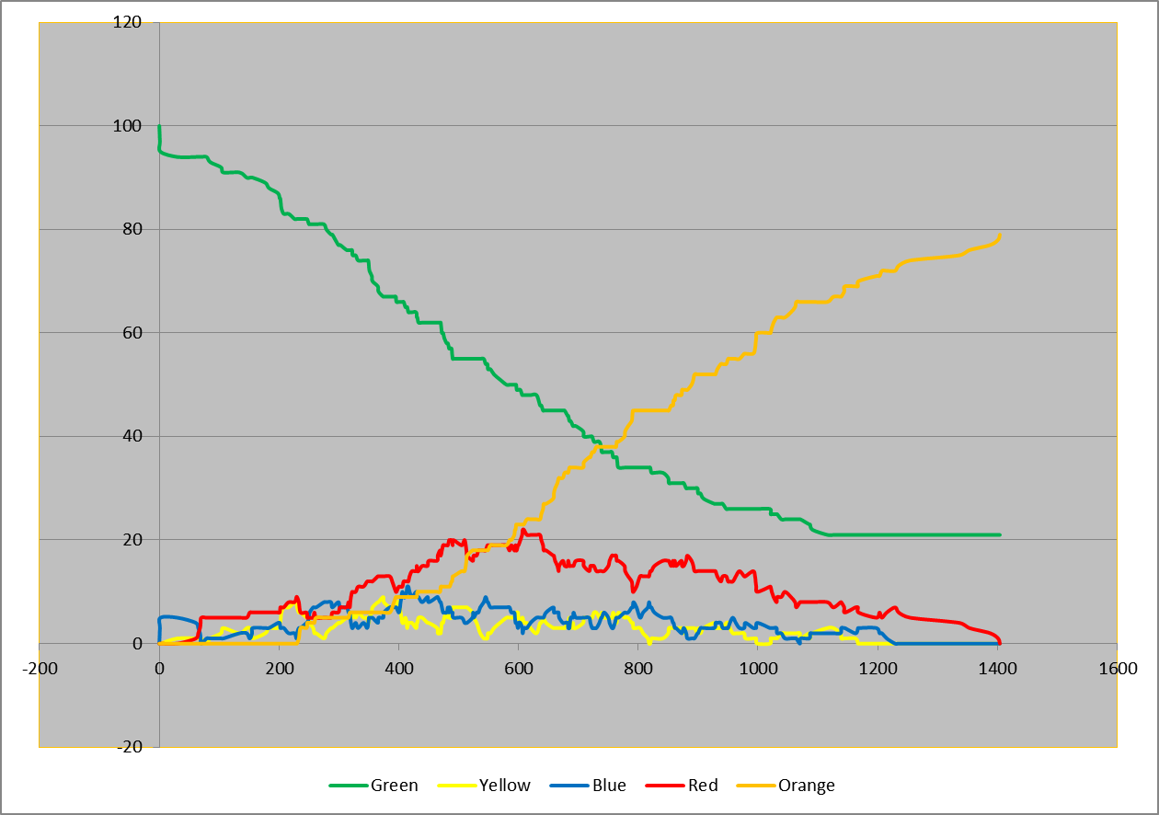

The data, graphed more precisely in Excel post-mortem, looks like the chart on the right. Stacking the counts to represent the proportion of the viral states among the agents in every generation produces this chart:

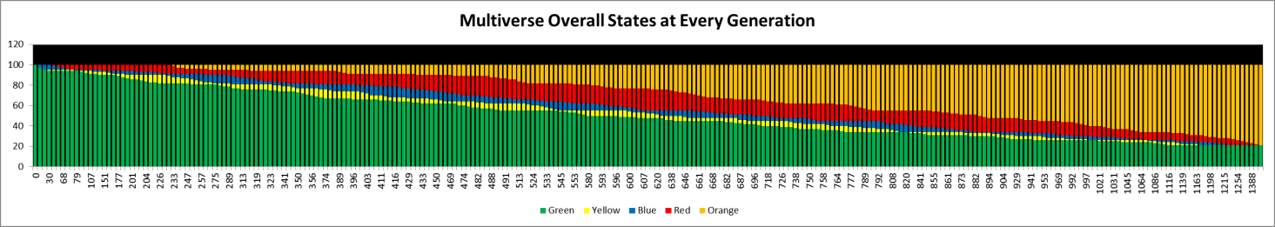

This chart shows the general decline of susceptibles over time with fluctuations in the heights of yellows which of course are flowed by increases in blues. The decreases in yellows remain to be explained, but raises the possibility that the stochastic movement of agents based on Pareto-like distribution means that they move a larger distance infrequently but with a probability larger than zero, and it is these bursts which lead to new areas where there are more susceptibles in terms of spatial density, leading to a larger local set of infections. When there is local exhaustion, new infections fall off, until another fruitful foray is encountered. This heterogeneity of stochastic movement is being explored in continuing research.

*The Viral State Time Map for Universe 0*

This representation seems to be most informative – there are 11 agents in every non-empty generation.

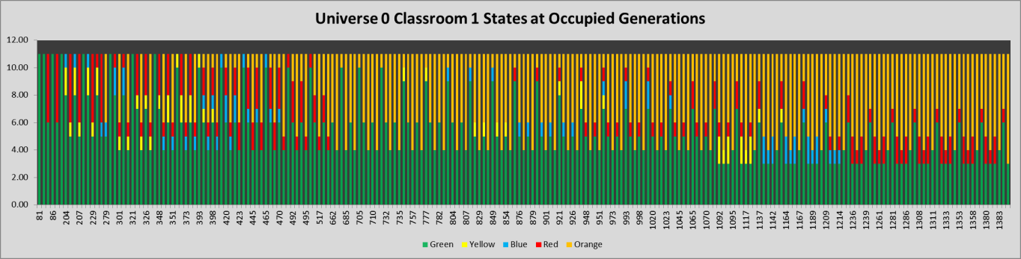

Recall that this chart reflects the output to console.log, which only happens when there is a change, and the empty Universe 0:0:0:0:0 has been suppressed. All the Universes except U6 LTC and U8 have such empty periods.

This shows that yellows (infections) do not occur uniformly but heterogeneously through the time dimension. We will see whether this is consistently the case. However, recall from the first SIMULTANEITY chart that U0 and U1 had no infections. Thus, in Universe 0 (Classroom1), despite the presence of up to 5 infectives, no infections took place among the occupants, including between students and teachers.

*The Viral State Time Map for Universe 1 (Project Room)*

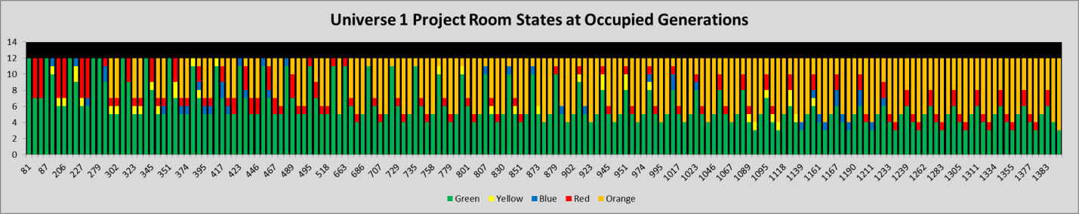

Similar to Universe 0, no infections took place in this Project Room. The constant occupation count is 12, and various infectives (red and blue) come through, but the combination of population density (12 in a fixed arena of 800x600 pixels) with a Hazard Radius of 5 and the mF for the Universe + occupants was not enough to disturb the continuity of 4 greens to the end of the trial.

*The Viral State Time Map for Universe 2 (Playground)*

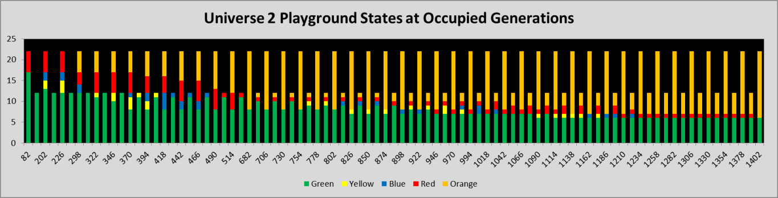

From the first SIMULTANEITY chart, Universe 2 had 4 infections out of a total of 35 different persons who go through the Playground. The chart above shows a constant maximum of 22 persons – this is 2 groups of students and 2 teachers, but there is another hour in which one group of students and 2 teachers are present – that accounts for the lower set of numbers. Again, note the irregular appearance of yellow new infections, which occur in clusters. The first 5 red agents in the very leftmost stacked column correspond to the initial 5 cases from the Group B students.

Four infections took place in Universe 2. The SIMULTANEITY chart shows that these occurred at approximately 100, 200, 300 and 320 generations. We cannot tell from this chart when the infections were, especially because the infection is recorded when it happens but the state change is done the next generation, and the agent may have left the Universe by then.

*The Viral State Time Map for Universe 3 (Lunchroom)*

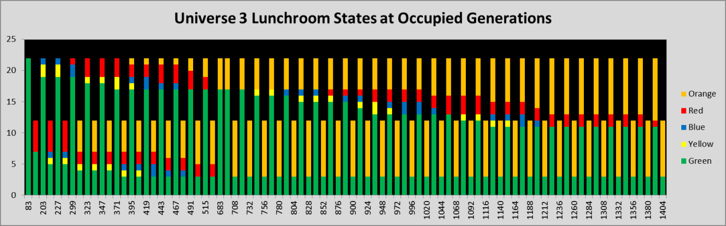

The Lunchroom had only 2 infections, late in the trial at generations 900 and 1100 approximately. Here we have the usual clustering of yellows (infectives) but we know they entered the Universe in this state, and at generations 900 and 1100 it is not possible to tell whether any yellow agents there were infected then and there, or entered the Universe in the infected state.

From 1212 generation on, the red agent is contemporaneous with 10 greens, but does not infect, while the 2 stable greens with all the orange agents adding to 12 clearly evolved from the 12 counts at the very beginning.

*The Viral State Time Map for Universe 4 (Classroom 2)*

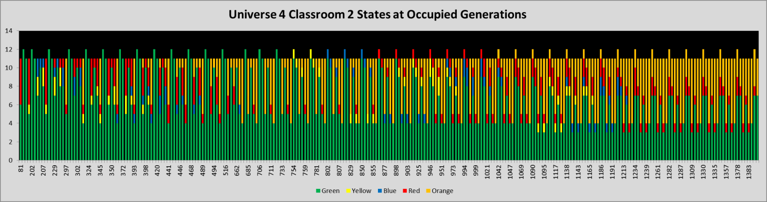

Universe 4 (Classrooom 2) had only 3 infections, the first around gen 350, the next two around 920 and 1100. Yet there are so many different state changes which is not the case for U3, with 2 infections, or U2 with 4 infections. The total population was also small, only 12.

However, the schedule above shows Classroom2 being used for 6 hours, by student groups A, B and C and teachers T0, T2,T3,T4 and T5. Gp C used this U4 3 times, GpA twice, and GpB once. Thus, 35 different agents circulate through U4 daily, even though the maximum at any one time is only 12.

This is a feature of the real-life use of spaces, in which different mixes of individuals can occur. For example, T3 is exposed to Gps A and C, but T5 is exposed to Gps C and B on the same day. This complexity is not shown by the chart, and the 12 persons and the 11 persons shown may not always the same 11. The chart will not show the difference between GpC with T5 and GpA with T3 if the state compositions are the same, and when there is a change, we don’t know from the chart which group and agent was involved, just that a structure change had occurred.

Again, we see here the irregular scattering of infected in this Universe, and we may be sure, since yellows only last for 2.2 days, that most of the yellows are just passing through.

*The Viral State Time Map for Universe 5 (Teacher’s Lounge)*

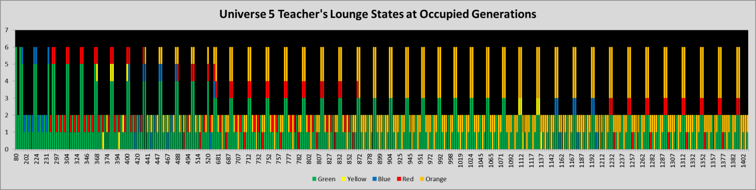

Universe 5 Teacher’s Lounge had no infections recorded within it, but 4 of 6 teachers got infected somewhere. This chart shows the viral states of the 6 teachers as they come and go in the Teacher’s Lounge. Again, we see the irregularity of the pattern of reds and yellows…the reds do not show up from gen 899 to 1237, because they have turned orange and there have been no new infections till 1122. This infection at this time is at the end of a temporal chain of repeated failures until the stochastic occurrence of an infection at gen 1122, and it must be in a low probability Universe like U7 the Bar, or in the school.

*The Viral State Time Map for Universe 6 LTC*

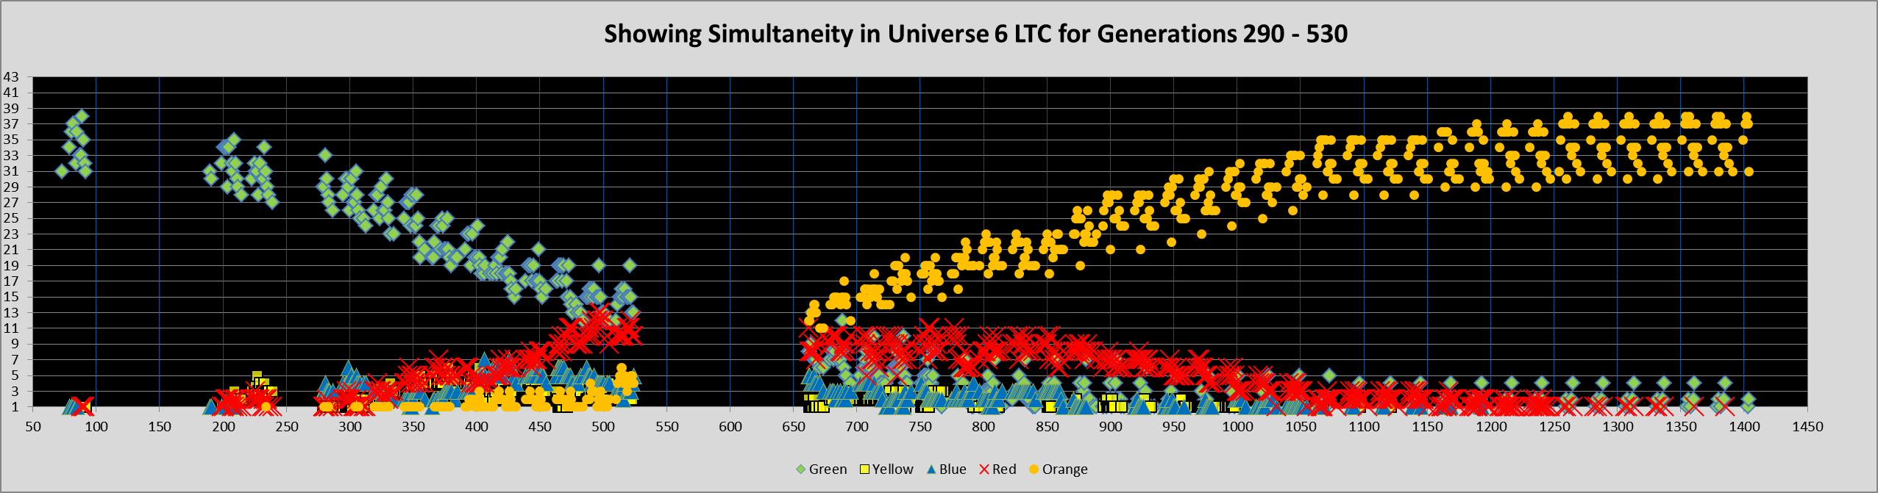

The gap in the middle is due to the suspension of recording in the Universes from gen 530 to gen 530, but activity was continuing, so this is presented as an interesting anomaly, showing that the gap does not affect the trends that are visible here.

First of all, the residents number 28, but there are 14 staff and 32 visitors daily. However, they are not all at the same hour, and our charts are by generation (hour), so in fact, the maximum per hour is only 43. The state structures are only collected when there are changes. The time line is continuous, so where there were no changes, then blanks appear as in the period between gen 100 to gen 180. Whether this blank period is due to stochasticity or to structural relationships in the schedule is unclear at this time.

We expand the period from gen 290 to gen 550 for clarity.

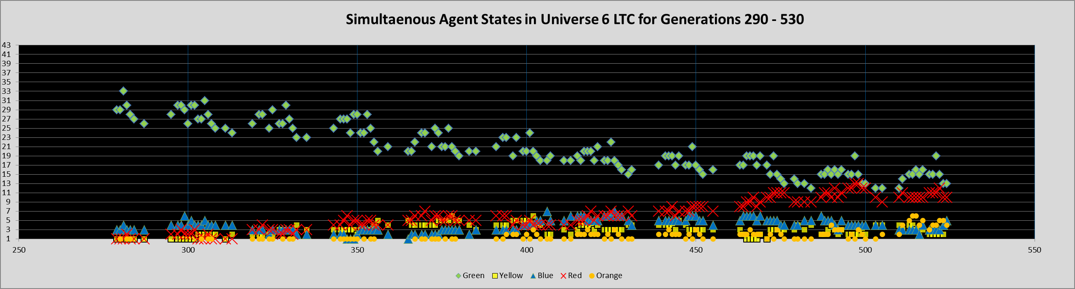

This is the first Universe that has shown an orderly progression (in this time region anyway) of a progressive decline in green susceptibles, while the rise in yellows, blues, reds, and oranges appear equally smooth, although the gaps between the clusters deserve further exploration.

*The Viral State Time Map for Universe 7 (Bar/Receptions)*

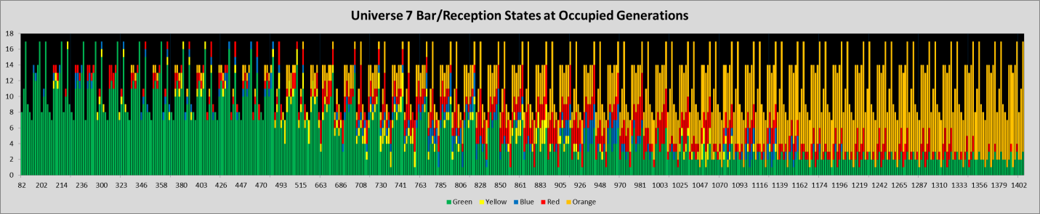

We purposely made the bar staff and client schedules complex. At this point, we don’t know whether detailed complex schedules are overshadowed by stochasticity, or whether the realism of heterogeneous schedules and mixes of persons create appropriate instabilities.

Here is the schedule for 3 bar staff (total 10).



The columns are hours of the day, and the entries are the Universes – so the first bar person in the second row goes to U7 Bar at 10am for a shift till 1700 hrs, then visits LTC U6, then goes home till 2200 when they go to the bar U7 for recreation for an hour, then home. In our system, travel takes no time.

The client schedule is equally complex.



Since the time chart is by generation, we can see that every generation, people are entering and leaving the bar. ONLY four infections took place in the bar, at generations 550, 640, 700 and 770 approximately. The detail of the time chart for the period 6500 to 800 is shown here, in a different chart format, to highlight the variation by the hour, and to show the gaps corresponding to the CLOSED bar.

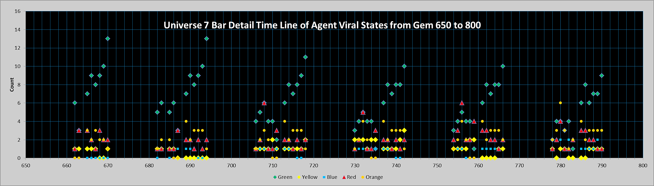

It is not possible to tell which yellow was a transit of an already infected person, and which was the new infection. There are many changes in color and configuration between the cluster at 710 and the cluster at 730.

*The Viral State Time Map for Universe 8 (HOME)*

HOME is the Universe in which persons have to go when things close down and people get off work. In this Universe, only members of the same family can infect one another, even if they make contact with others repeatedly.

In this Universe, 13 infections took place, five of them being five of the first 8 infections in the Multiverse. No doubt this is because the trial starts with midnight, and there are 8 hours for HOME families to be in contact, even though their mF is set low for sleep hours, while during evening and day time, HOME mF for agents is set higher.

Here is the time chart for U8.

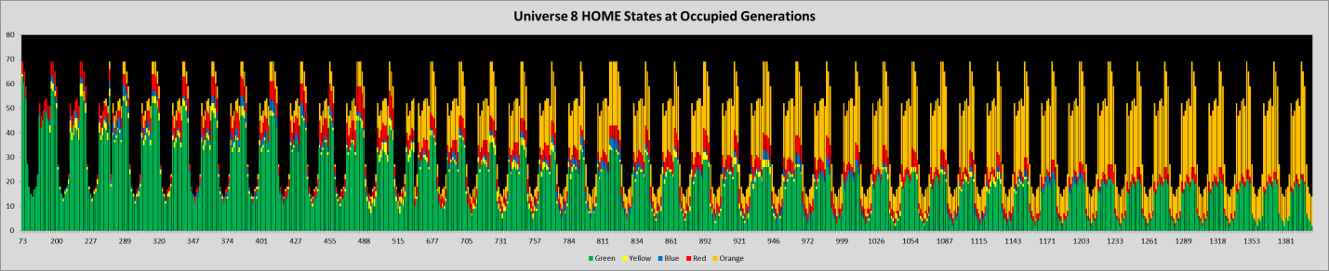

Notice that the count of agents in U8 is 70 (28 being LTC residents), and someone being away at all times because of the night shifts at LTC for staff. The big dip is due to most people leaving to school, teach, bar, visit LTC, but there are a small number who remain every hour, essentially assigned maintenance work around the HOME universe.

In the valleys, there are complexes of different viral states. The chart does not distinguish between families, so these shifting viral agent states could well be from different agents, because agents do not occupy a position on the column – the column just represents counts of different states for any given generation.

***SUMMARY OF VIRAL STATE TIME MAPS***

For each Universe, these show the gradual shift in the composition of the agents who arrive at and depart a Universe after a period of time. They give some insight into the overall potential for infection within each Universe, but do not show the actual infection, if any, that occurred in a Universe, nor who the agents are that shpw up in different states per generation. This is a very rough scan of what essentially are surface features of the dynamics of the Multiverse

**WHAT WE SEEK TO REPRESENT**

The metrics for the Multiverse show the rough features of the entire population and their changes over time in the simulated epidemic: how long it took to terminate, how many survived, what cohorts and Universes had the most infections and the largest theta (least risk) and the smallest. With the overall transmission tree, we can get an estimate of the intensity of the overall epidemic.

The first SIMULTANEITY chart showed the Universes in one time-line separated, with infection events along the time-line, which is more than the scalar metrics described above.

What Is difficult to grasp are the dynamics of how the epidemic is conveyed from Universe to Univserse, such that we could identify critical flow paths upon which the progress of the epidemic might be more dependent. If these exist, then we could simulate mitigations at these flow junctions. This might call for a strong dependency map which expresses both volume and temporality. In other words, if choke points exist, they may be there for just a period of time when the flow rate or volume is at a critical point. We have not yet been able to develop tools in the Multiverse to approach this challenge. However, here is SIMULTANEITY CHART II, which goes beyond the first, that presents Universes along common time-lines, to agents along common time lines.

**SIMUlTANEITY CHART 2**

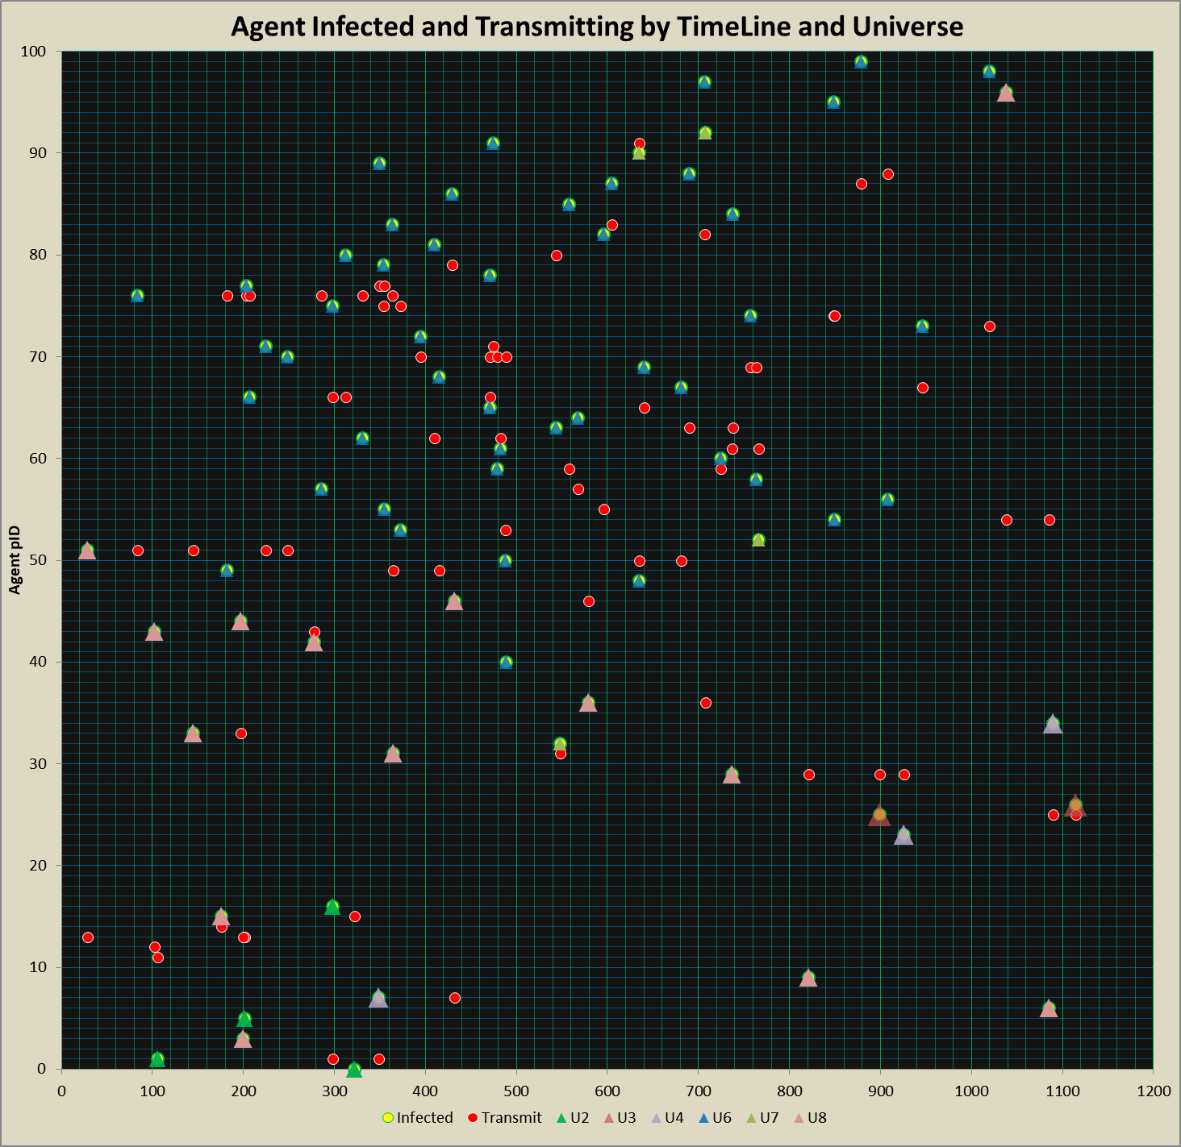

The Y-axis are the agent pIDs. The X-axis is the generation time-scale, from 0 to 1200. Along the x-axis, each agent shows their behavior, starting with when they become infected. For example, looking at agent 70, we see that there is a blue triangle on top of a yellow circle. The legend says that this means that agent 70 became infected (yellow circle) in Universe 2 (blue triangle). This holds true for all agents except 10-14, which are initial cases. They can be seen along the Y-axis appearing as red circles (“Transmitter”) without a preceding infection action in a Universe.

Returning to agent 70, we see that as time line proceeds, agent 70 has 4 more reds along its journey, near 400 and three near gen 500. Then agent 70 becomes queiscent (and we know it only has at most 13.2 days after it becomes infected – turns yellow). So none of these action lines are very large, and by examintion, the largest appears to be agent 76, with 5 infections between gen 180 and gen 380,

Unfortunately this SIMULTANEITY chart does not tell us what Universe the agents were in when they did their transmitting actions, nor who they infected. We can with a bit of Excel labor, add the Universe overlay for the infection action for the red agents, but to link to the agent that they have infected is to risk creating an entire mess of spaghetti lines.

However, not all is lost, because actions take no time, and therefore each infection event is accompanied by an agent becoming infected on the same generation Y-line. This means that for the agents that have a red infection event, on that same generation, there will be a yellow circle with a blue triangle.

If there is simultaneity, such as at generation 430, we will not be able to distinguish which infection corresponds to which transmission. We have on generation 430, two transmission events (red circles), for agent 7, and for agent 79. We also have infections (yellow circle, colored triangle) for agent 46 in U3 (plum triangle), and for agent 86 in U6 (blue triangle).

If we did have the Universe of infection for the red event, we would have a better chance of matching. This we can do in the next iteration of trials.

However, we are not any closer at this point to understanding whether the growth of infection-laden traffic between Universes is critical to the growth of infections within Universes, although we have meters on the traffic that flows in and out of every Universe. The composition of viral states in a Universe is tracked, but we have not used the source of these agents with their states to try to understand the flow-through of agent-states (which we mainly see) versus the infections that would not happen if there were not flow-through.

**DISCUSSION**